Henry Ford College Career Services Office

Career Planner

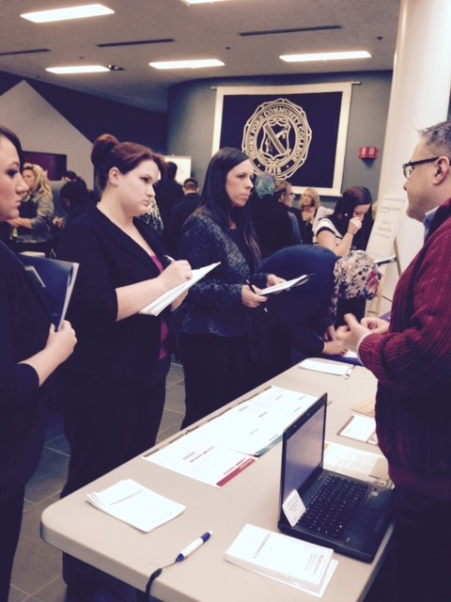

Before everything else, getting ready is the secret of success.
- Henry Ford

Contents

Explore …………………………………………………………………………………………………………………… 4
Using Information Interviews & Shadowing to Find Your Career ………………………………………………..5
Finding a Profession(al)
Asking Questions
Following Up Your Interview
Help Your New Grad Find a Job ………………………………………………………………………………........6
Tips From Employers Who Are Hiring …………………………………………………………………………….. 7
Perfect Your Qualifications
Get Experience
Build a Network
Career Exploration – Get the Facts ……………………………………………………………………………….. 8
Top Job Sites ……………………………………………………………………………………………………….. 10
Job Search Sites ……………………………………………………………………………………………………. 11
Relevant Work Experience a Kay for Job-Search Success ……………………………………………………. 12
Effective Networking the Key to Job Search Success ………………………………………………………….. 13
Prepare ……………………………………………………………………………………………………………………14
Resume Check List …………………………………………………………………………………………………. 15
Resume Rubric ……………………………………………………………………………………………………… 16
Robert Fictional – Sample Resume ………………………………………………………………………………. 17
Action Words ………………………………………………………………………………………………………… 18
Cover Letter Rubric …………………………………………………………………………………………………. 19
Robert Fictional – Sample Cover Letter …..……………………………………………………………………… 20
10 Tips for Top Notch References ………………………………………………………………………………… 21
Robert Fictional – Sample Reference Page ……………………………………………………………………… 22
Sample Faculty Reference Letter …………………………………………………………………………………. 23
Interview Rubric ……………………………………………………………………………………………………... 24
Do Your Homework before the Interview ………………………………………………………………………… 25
Employer Website’s
Research Employer’s
Pre-Employment Inquires Related to Disabilities………………………………………………………………… 26
Thank-You Notes …………………………………………………………………………………………………… 27
Connect ………………………………………………………………………………………………………………….. 28
When to Call …………………………………………………………………………………………………………. 29
Introductions and Whom to Call
Leaving Messages
Talking to Interviewer
Choosing Among Job Offers ………………………………………………………………………………………. 30
Benefits Count ………………………………………………………………………………………………………. 31
Health Insurance
Annual Salary Increases
Tuition Reimbursement
401(k) Plan
Tips for Maximizing Career Fair Success …………………………………………..…………………………… 32

Explore
- Focus II – an assessment test with the intent to help narrow down what you want to do for a living.
- Research – let us help you learn more about your dream job.
  - Pay rates, job availability, typical duties & more!
- Job search – there are TONS of on-line job boards out there!
- Articulation Agreements – a follow a plan here that will set you up to continue your education at a four year university.

Prepare
- Get assistance with – resume, cover letter, job search, interview
- Gain experience while continuing your education!
  - Work Study, Co-op, full or part time positions

Connect
- Network Network Network!
  - Interact with employers face to face through – career fairs and on campus recruiting events.
- Use social media to your benefit! Find employers on many of the top social media sites – Facebook, Twitter, LinkedIn
- Use your co-op or work study job to connect with employers

Explore

Using Information Interviews and Shadowing to Find Your Career
The best way to explore a potential career choice is by speaking with and/or following someone who works in that career. Do an information interview. Learn first-hand about your chosen profession by asking questions about tasks, business environment, and educational background. Shadow a professional. Follow someone in your career choice as they go through a typical day or week on the job. Ask questions and observe the work.

Finding a Profession(al)
Finding someone to interview or shadow is not difficult. Ask your parents and your friends’ parents if they know someone you can interview. Ask your professors for recommendations of professionals in the field. Go to your career center: Many maintain lists of alumni and employers who are willing to help in your career exploration.
Next, call or write a letter requesting an information interview or job shadowing. People who like their jobs tend to enjoy talking about them. You compliment the professional by expressing an interest in the career. In your phone call or letter, explain how you found the person you want to interview and request time for an appointment. Emphasize that you want to find out more about the career—you’re not looking for a job. If you’re lucky, the professional you contact may have other colleagues you can interview also.

Asking Questions
Takes notes during your time with the professional. Here are some questions you might ask:
- What is your typical workday like?
- What do you like most (and least) about your job?
- What skills/abilities are most important to succeed in this job?
- What is your educational background?
- How did you get started in this field?
- What courses were most helpful to you and which would you recommend?
- What is the best way to get started in this field?
- Do you have any additional advice to help me prepare?

Following Up Your Interview
Review your notes. What was your impression? Did you leave the interview feeling as if you can envision a future in this occupation or were you discouraged—you don’t feel you learned enough about the occupation or the job description doesn’t sound appealing any longer?
Take your thoughts and concerns to the career center staff and get feedback on the next step to take in your career exploration. You may want to do additional information interviews in this career path or you may want to reexamine your goals and find a different path for your interests.
No matter what you decide, send a thank-you note to anyone you interview or shadow. Whether you decide to forge ahead on that career path or find another one, this professional may be a good person to network with when you begin your job search.
Courtesy of the National Association of Colleges and Employers, copyright holder. www.naceweb.org.

Help Your New Grad Find a Job

As parents of graduates facing a tough job market, what can you do to assist your son or daughter in transitioning from the secure world of classes and residence halls to the unknown reality of what lies ahead? Here are some suggestions:
Ask how you can help.
Your son or daughter may have specific ideas about ways you can assist. Your editing skills may be the second pair of eyes needed to critique a resume; your managerial skills could be useful as a mock interviewer; your research skills might uncover some new job leads. Think about how your role as something other than mom or dad could be helpful.
But don’t be pushy: Let your new grad take the lead.
Suggest a visit to the campus career center.
The campus career center provides a wealth of job search resources—job postings, career fairs, resume assistance, and career counseling, just to name a few. Make sure your son or daughter is aware of the office. If your new grad isn’t near his or her alma mater, suggest that he/she call the career services offices at local colleges and ask if help is available.
Offer networking contacts.
Networking is one of the most effective ways to find a job. With your child’s permission, talk to your co-workers about your son or daughter’s job search. Discuss it with neighbors and friends. You never know who may know of a job opportunity.
Be ready to hear new ideas.
Your new grad may mention attending graduate school or raise a new career goal. Listen to new ideas with an open mind, making positive suggestions when appropriate. Ask open-ended questions to show your son or daughter that you’re interested—and the answers will help your new grad think through the new ideas.
Provide a sounding board when frustrations overflow.
The nightly news about unemployment is stressful. Imagine trying to complete your studies and conduct a job search, too. If your child calls to talk, but really needs to vent, listen. Sometimes the best thing you can say is nothing at all.
Give an early graduation present with the job search in mind.
Don’t wait until May to say congratulations. Now is a great time to give a graduation present that will be used during the job search and first year on the job. Looking for ideas? Interview suits, briefcases, portfolios, and memory sticks are great gifts for the new grad.
Reassure your new grad that a tough job market is temporary.
The ebb and flow of the economy is constant, and brighter days lie ahead. You’ve likely experienced similar ups and downs. Convey your experience to your new grad.
Look and listen for signs of depression.
If your son or daughter talks about skipping class, exhaustion, or loss of appetite, he or she might need some help. If your student is still on campus, contact appropriate campus representatives (residence life offices, counseling centers, and so forth) for help.
Remind your new grad that you are proud of his or her accomplishments.
A sour economy should not take away the success of earning a college degree. Be sure your son or daughter knows that you are proud of this achievement. Send a card or make a phone call to specifically convey this message.
by Kelli Robinson. Courtesy of the National Association of Colleges and Employers, copyright holder.

Tips From Employers That Are Hiring

The best job-search advice comes from the employers that are hiring. If you take the time to follow this advice, you'll be better prepared than your competition for your application and interview.
Here are some things you can do to aid in your job-search success:
Research the Company
- What products or services does the company produce and sell?
- Where is it located?
- How well did the company do last year?
- What activities by this company have been in the news lately?
Learn something about the company with which you want to interview. Read its website and its annual report. Search for news stories mentioning the company. Use this information to customize your resume and cover letter for the position you want. Impress the interviewer by knowing something about the company. (Learn more: See Researching Employers)

Perfect Your Qualifications
A high GPA is important. It means you know the subject matter. However, employers are looking for people with "soft skills," too—skills you can learn through extracurricular activities such as leading a team, taking part in a group task, or organizing a volunteer project. Employers want to find communication skills, a strong work ethic, teamwork skills, initiative, the ability to relate to co-workers and customers, problem solving skills, and analytical skills.

Get Experience
Year after year, the majority of employers taking part in a survey conducted by the National Association of Colleges and Employers (NACE) say they prefer to hire job candidates who have pertinent experience. For college students, typically, relevant experience is gained through an internship.
In fact, an internship can be the "foot in the door" to a job with many employers: NACE surveys show that newly hired employees often come from the organization's own internship program.

Build a Network
Whether you get the job you want—or even hear about the job opportunity you want—could easily depend on who you know.
Here's where you will find people to build your professional network:
- Business and professional social networking sites
- Professional associations (online and in person)
- Career fairs
- Company information sessions
- Your school's alumni network
- An internship or co-op program
- A student professional organization

Career Exploration – Get the Facts!
Career Exploration Options/Resources:

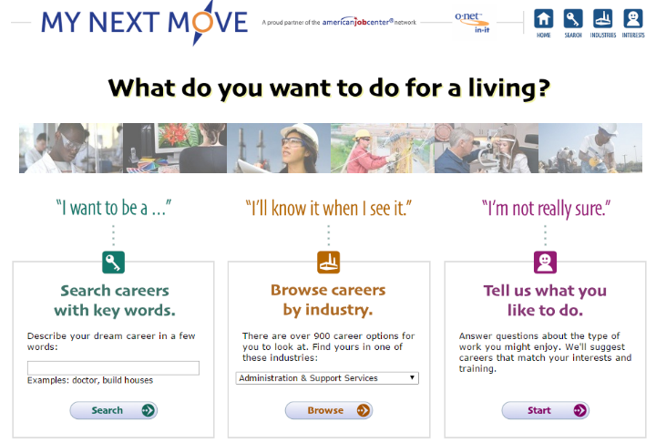
- My Next Move
http://www.mynextmove.org/

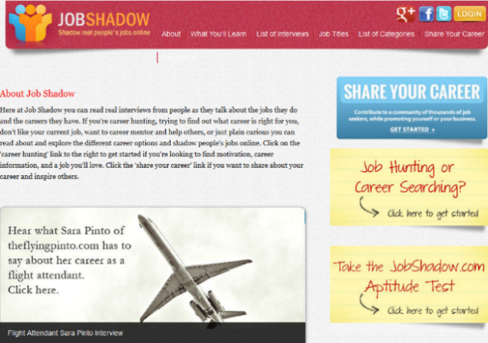
My Next Move is an interactive tool for job seekers and students to learn more about their career options. My Next Move has tasks, skills, salary information, and more for over 900 different careers. Users can find careers through keyword search; by browsing industries that employ different types of workers; or through the O*NET Interest Profiler, a tool that offers personalized career suggestions based on a person's interests and level of work experience. This site can give you a great overview of careers that may be a fit for you!

- Job Shadow http://www.jobshadow.com/

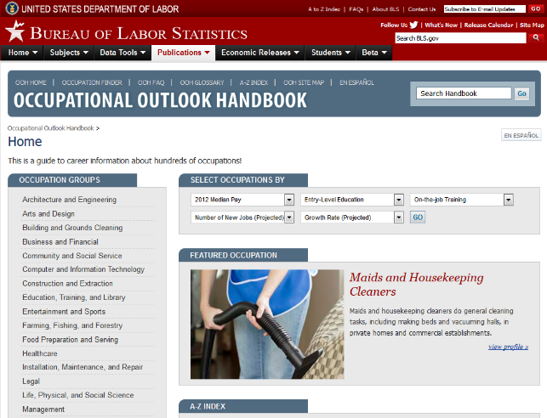
Job shadow is the website to go read about interviews from people. Real people talk about their experiences and the career they have. Read and explore the different career options. The #1 online destination for people searching for quality career information and inspiration.

- Occupational Outlook Handbook
http://www.bls.gov/ooh/
The Occupational Outlook Handbook (OOH) is an online career guidance resource that provides information on hundreds of occupations in the United States. Updated every 2 years by the Bureau of Labor Statistics (BLS), the OOH allows students to explore different aspects of occupations in greater detail than ever before.
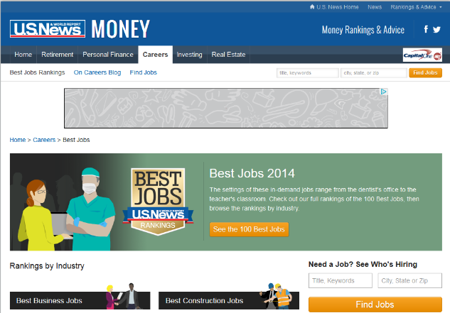
- US News & World Report
http://money.usnews.com/careers/best-jobs/accountant
A great independent source for career advice and information. US News & World Report is recognized as one of the best research and analysis publications in the world.

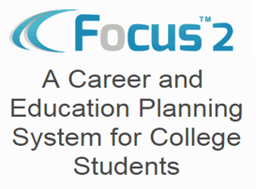
5.) FOCUS2
https://www.focuscareer2.com/Index.cfm

Establish a baseline – Find out what your academic strengths and weaknesses are. Explore potential careers based on degrees and certificates offered here at HFC. Search through detailed descriptions of 1000+ occupations on their extensive database. Compare occupations side by side. Use stepping stones to enhance your college experience and help move you toward your goals.

You will need to create a log in using your hawkmail and the access code Hawks

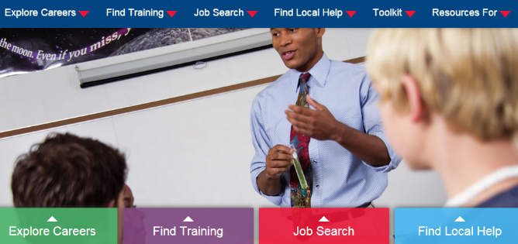
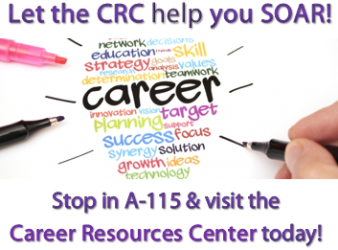
6.) Career Resources Center
https://www.hfcc.edu/campus-life/counseling/career-resource-center

The purpose of the Career Resource Center (CRC) is to assist students, alumni, and community members with career decisions. Whether you're making your first career decision or changing your career direction, you're invited to visit the CRC and work with a professional counselor to assess your career situation.

Monday – Thursday 10:00 am – 2:00 pm
7.) CareerOneStop
http://www.careeronestop.org/

Your one stop shop for information on career exploration, training, and job opportunities. Get answers to your top questions, job search document resources, and stay up to date with what is trending in fields that interest you!

Top Job Sites

Here are some great job sites the Career Services Office recommends you check out!

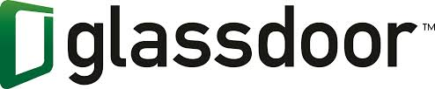
HFC Job Leads
careers.hfcc.edu/
Social Connection
www.linkedin.com/
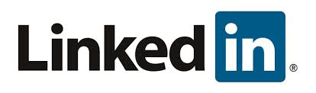
Top Search Sites
www.indeed.com/
www.symbaloo.com/profile/cso
www.simplyhired.com
www.idealist.org/
www.glassdoor.com/index.htm
www.internships.com
www.dice.com
Canadian Job Site
www.wowjobs.ca

Job Search Sites

General Sites:

AllStar Jobs www.allstarjobs.com
Beyond – The Career Network www.beyond.com
Career Exposure www.careerexposure.com
Career.com www.career.com
CareerAge www.careerage.com
CareerBuilder www.careerbuilder.com
CareerOneStop www.careeronestop.org
CareerSite.com www.careersite.com
Contract Job Hunter www.cjhunter.com
The Career Key www.careerkey.org
Health Care/Medical Sites:
Health eCareers Network www.healthecareers.com
Medzilla www.medzilla.com
Human Resources Sites:
HR Connections www.hrconnections.com
HR Hub www.hrhub.com
International Sites:
EscapeArtist.com www.escapeartist.com
International Job Center www.internationaljobs.org
LatPro (Spanish) www.latpro.com
OverseasJob.com www.overseasjobs.com
Wow Jobs (Canada) www.wowjobs.ca

Relevant Work Experience a Key for Job-Search Success

We know that recruiters looking for candidates to hire for their organizations want college graduates who are a proper fit for their culture and industry. But, without being hired full time, how can you demonstrate that you can perform at a high level on the job?
The best way to impress potential employers during your job search is to gain and highlight relevant work experience.
Nearly three-quarters of the employers taking part in the National Association of Colleges and Employers’ (NACE) Job Outlook 2012 survey said they prefer to hire job candidates who have pertinent experience. On the other side, just 4 percent of employers said experience didn’t factor into their decision when hiring new college graduates.
For college students, relevant experience is typically gained through internships. In fact, an internship can be your way to get your “foot in the door” to a job with many employers: In a separate NACE study regarding internships, responding organizations reported that 42 percent of their 2011 college hires came from their own internship programs.
Simply put, employers are looking for evidence that you can do the job; the internship provides you with that evidence. Be sure to visit the career services office for guidance on internships that can support your career goals.
Courtesy of the National Association of Colleges and Employers, copyright holder. www.naceweb.org.

Effective Networking
The Key to Job Search Success
Networking is one of the fastest ways to find new opportunities for your career, but it's also one of the most daunting. Walking into a room full of people you don't know, trying to think of a clever way to ask for a job -- is it any wonder that networking is often passed over for less interactive forms of job searching? Here are the five things you want the people you're networking with to know about you:
1. Your contact information and "elevator pitch"
You should always carry business cards with you, but it's especially important at a networking event. Even if you're currently employed, having a quick and convenient way to give someone your contact information makes it easier to make connections. There are websites that will print affordable, custom business cards for you. Include your name, title or industry, email address and phone number, as well as any personal websites or online portfolios.
This is your chance to brand yourself, so think about what you want others to know about you and what kind of relationships you're looking to establish. Practice introducing yourself in less than 30 seconds. Giving a new contact your "elevator pitch" helps you speak about yourself confidently, and sharing your business card communicates that you're interested in establishing a professional relationship.
2. Something that makes you a specialist in your field
After initial introductions, share something that establishes you as a specialist in your field. Maybe you are an accomplished salesman, were recognized in your discipline or work with a niche group of customers. Just as in a job interview, have an answer for why you're a leader in your profession. You want to give people you meet a reason to want to talk to you, instead of somebody else in your field.
3. A creative project you're working on, either on your own or at work
Initiative is a favorite business buzzword, but it does have merit and is worth mentioning. Demonstrate your ability to act on your own and make hard decisions by discussing a side project, such as launching a website, writing a book or leading a team. You may find somebody who has valuable insight on your project or who may be interested in collaborating on it.
4. You're interested in their profession, too
After a conversation ends, you don't want a person's memory of you to be, "Me, me, me." If done incorrectly, networking can turn into two people talking about themselves and asking each other for favors. Take the time to get to know the person with whom you're speaking. Share your "elevator pitch," convey why you're a specialist and mention current projects, but take the time to hear his point of view, too. After networking, can you recall the people you spoke with because you have a better understanding of who they are? Or can you only recall what they can do for you?
5. Something unique that will make you stand out
Sharing a unique personal story or entertaining fact is a good way to stay memorable after a networking event. You'll not only prove that you know your business and strengths, but you'll also show that you're personable and get along well with others. Have fun and be yourself, and people will want to network -- and work -- with you.

Prepare

Résumé Checklist

- Résumé has an inviting, uncluttered look, incorporating sufficient white space
- Avoid underlining, as this interferes with many lower-case letters
- Use a standard font style (Arial, Tahoma, or Calibri) and size (10-12 pt.)
- The design is basic and conservative with narrow margins
- Include complete contact information name, address, phone, and appropriate email
- Contact information is attractively formatted to introduce the resume
- Section titles showcase education, experience, and accomplishments
- Consistently use bullet points (not paragraphs), and avoid complete sentences
- Always put most important information first
- Résumé is oriented to the future rather than to the past
- Résumé is unique to each desired position and employer
- Did not refer to myself as “Me, My or I”
- Include dates for experience, but place in a less prominent area such as right side of the page
- No time gaps, nor “job hopping” are apparent to reader
- Use unique and precise action verbs and an active voice
- Phrases are short and concise using expressive, and direct language
- Eliminate all extra information unrelated to employers’ needs
(Avoid information about: race, religion, political affiliation, age, sex, height, weight, marital status, health, hobbies, salary history, or references)
- Include unique skills such as technological knowledge, lab competencies, and languages
- Limit abbreviations to accepted words only
- “Experience” section is short and to the point with no more than 4-5 jobs and no more than 7-8 bullet points for each

Resume Rubric

 | Resume should effectively land you an interview. | Resume could land you an interview (borderline case). | Resume is average, needs improvement to rise to the "top of the stack." | Resume needs significant improvement and would be discarded during screening
Format | This resume fills the page but is not overcrowded. There are no grammar or spelling errors. It can be easily scanned. | This resume almost fills the page, but has some uneven white space. There may be a single spelling or grammar error. | The font and spacing of this resume are not appealing and cannot be easily scanned. There are spelling errors and grammatical mistakes. | This resume is either one-half page or two to three pages long. The font is too big or may be hard to read. There is more white space than words on the page. There are multiple spelling and/or grammar errors.
Education Section | This section is organized, clear, and well defined. It highlights the most pertinent information and includes: institution and its location, graduation date, major, degree, GPA, study abroad (as appropriate), and any relevant course work. | This section is well organized and easy to read. It includes institution and its location, graduation date, major, and degree. GPA and “extra” information, such as study abroad and course work are missing. | Information such as institution and its location, graduation date, and major are included, but degree and GPA are not listed. This section is not well organized and there is no order to how information is formatted. | This section is missing the most crucial information. Institution is listed, but not its location and graduation date is missing. The major is included, but not degree. No GPA is stated.
Experience Section | This section is well defined, and information relates to the intended career field. Places of work, location, titles, and dates are included for each position. Descriptions are clear and formatted as bullets beginning with action verbs. (This section could be split into related and other experience.) | Places of work, location, titles, and dates are included for each position. Descriptions are formatted as bullets betinning with action verbs, but are not detailed enough to help the reader understand the experience. Information does not relate 100 percent to the intended career field. | Descriptions are not presented in bulleted lists that begin with action verbs. Instead, complete sentences in paragraph form are used to describe positions. Places of work are included for each position, but not locations, dates, and titles. | There is no order to the descriptions of each position. Descriptions are not detailed and don't illustrate the experience. No locations and dates of employment are listed.
Honors/ Activities | This section is well organized and easy to understand. Activities and honors are listed, and descriptions include skills gained and leadership roles held. Dates of involvement are listed. | This section includes all necessary information, but is difficult to follow. Leadership roles within organizations are listed, but skills are not defined. Dates of involvement are listed. | This section is missing key information such as leaderships positions held or dates of involvement. Organizations are listed; the organization, not individual involvement in each, are described. | This section is missing—or contains very little—information. Organization titles or dates of involvement are not included, and there are no descriptions.
by Amy Diepenbrock. Courtesy of the National Association of Colleges and Employers, copyright holder. www.naceweb.org.

** This is an approved format for preparing your resume. Upload your finished product to your HFC Job Leads account at: careers.hfcc.edu**

Robert Fictional
3333 Imaginary Rd. Empty Township, MI 48888
Home (555) 555-5555 / Cell (555) 777-7777
example@example.com

Objective Seeking the position of ______ [Put actual job title in if known] with ______ [Put in actual company name if known] where valuable experience can be gained and education can be utilized to benefit your company.
[Keep your objective as specific as possible and to the point.]

Education Henry Ford College, Dearborn, MI May 2016
Associate in Applied Science Degree GPA 3.5
Electrical Technology
[Highlight things such as your degree and job titles by bolding or italicizing]

Experience Clerk May 2014 - Present
ABC Dollar Store, Some City, MI
- Prepare store for opening and closing
- Market store products and services to customers
- Coordinate and schedule deliveries with various vendors
- Collaborate on projects with other staff members
- Organize and input daily sales totals into company computer system
[Notice the use of verbs to begin every line. Always start off work descriptions with an action verb i.e. something that you actually DO]
Ride Coordinator May 2013 - Sep 2014
AB Funrides, Anywhere, MI
- Researched and responded to customer concerns
- Ensured customer safety
- Processed monetary transactions
[Notice verbs are now put in past tense. This is a very common mistake. Past jobs that are no longer current need to be put in past tense.]
Junior Varsity Lacrosse Coach Aug 2012 - Dec 2012
Notreal High School, Somewhere, MI
- Managed a team of 16-18 players
- Devised and taught strategic goals and concepts
[Don’t worry if you don’t always have a lot to put down for a job but make sure what you do put down is RELEVANT to the job you want. Don’t put down job activities that will not help you get the job your objective is crafted for]
Sales Counselor May 2012 - Oct 2012
Sample Store, This Place, MI
- Tabulated worked hours and salary
- Marketed company’s services and product to customers
- Established sales goals and sold product to consumers
[Second bullet is removed because the same experience is highlighted in the first job, second bullet. Do not repeat experiences.]

Honors & Activities Coach- Fictional Youth Baseball Team Sep 2013 - Present
Recipient- Sales Team Excellence Award, ABC Dollar Store May & Jun 2014
Volunteer- Mountain City Nursing Home May 2013
President- Baking Club, Henry Ford College May 2015- Present

Computer Skills Microsoft Office- Word, Excel, PowerPoint
Google Analytic
Action Words
Describe your accomplishments using brief statement. Each statement should include action words. Example: “HTML Programming experience.” say “Created client websites using HTML programming.”
Always be sure to maintain the proper tense when describing past and present jobs.

Abstracted
Accepted
Achieved
Acquired
Acted
Adapted
Addressed
Administered
Advised
Allocated
Analyzed
Anticipated
Applied
Appraised
Arranged
Assembled
Assert
Assessed
Assisted
Attained
Audited
Budgeted
Built
Calculated
Classified
Coached
Collected
Communicated
Compiled
Composed
Computed
Conceptualized
Conducted
Confronted
Consolidated
Constructed
Consulted
Cooperated
Coordinated
Corresponded
Counseled
Counted
Created
Critiqued
Enter
Decided
Decorated
Defined
Delegated
Designed
Detected
Determined
Developed
Devised
Diagnosed
Directed
Discovered
Displayed
Drew
Earned
Edit
Edited
Eliminated
Empower
Empowered
Endure
Enforced
Entertain
Entertained
Established
Estimate
Estimated
Evaluated
Evaluating
Examine
Examine
Examined
Expanded
Experimented
Explain
Explained
Financed
Fixed
Formulated
Gathered
Generated
Greet
Greeted
Grossed
Group
Facilitate
Guided
Handled
Hire/Fire
Hired/Fired
Hypothesized
Identified
Illustrate
Illustrated
Implemented
Improved
Increased
Initiate
Initiated
Inspect
Inspected
Install
Installed
Instituted
Instructed
Interpret
Interpreted
Interview
Interviewed
Invent
Invented
Inventory
Investigate
Investigated
Lectured
Listened
Locate
Located
Maintain
Maintained
Managed
Manipulate
Marketed
Mediate
Modeled
Monitored
Motivated
Negotiate
Negotiated
Network
Observe
Obtain
Operate
Operated
Ordered
Organized
Oversaw
Persuade
Persuaded
Photographed
Plan
Planned
Prepare
Prepared
Preserve
Printed
Prioritize
Processed
Produced
Projected
Proofread
Provided
Publicized
Purchased
Question
Read
Reason
Recommended
Reconciled
Record
Recorded
Recruit
Referred
Refined
Rehabilitate
Remember
Repaired
Represented
Researched
Resolved
Responded
Retrieved
Review
Run
Scheduled
Selected
Sell
Sketch
Sorted
Speak
Studied
Styled
Summarized
Supervise
Supervised
Support
Surveyed
Teach
Test
Tested
Train
Trained
Transcribed
Traveled
Troubleshoot
Tutored
Upgraded
Utilized
Wrote

Cover Letter Rubric

 | Cover letter should get you the interview. | Cover letter could land you an interview. This is an average letter (borderline case.) | Cover letter needs significant improvement and would be discarded during screening
Business format and overall quality of writing ability | This letter uses correct business format with date and addresses at the top, and a signature at the bottom. This letter is clear and concise, and grammatically correct. There are no spelling errors. | This letter uses correct business format with date and addresses at the top, and a signature at the bottom. There are minimal grammar and spelling errors. While its content is decent, this letter does not convince an employer to call. | Business formatting is not used in this letter. There is no address or date at the top. This letter is not signed. There are multiple grammar and spelling errors. The content of this letter does not make sense to the reader.
Section 1: Introduction | This section identifies the position for which you are applying and explains why you are interested in the job. You have described how you heard about the opening. The wording is creative and catches an employer’s attention quickly. | This section identifies the position you are seeking. This letter does not describe how you heard about the opening. You vaguely describe why you are interested in this job. This section is bland and might not catch someone’s attention fast enough. | This section does not clearly identify what position you are seeking. There is no description of how you heard about the position or why you are interested. This letter definitely will not grab an employer’s attention and keep him or her reading.
Section 2: Identification of skills and experiences as related to position | This letter identifies one or two of your strongest qualifications and clearly relates how these skills apply to the job at hand. This letter explains specifically why you are interested in the position and this type of job, company, and/or location. | This letter identifies one of your qualifications, but it is not related to the position at hand. This letter restates what is on your resume with minimal additional information. You explain why you are interested in the position but are too vague. | This letter does not discuss any relevant qualifications. You have not related your skills to the position for which you are applying. This letter does not state why you are interested in the position, company, and/or location.
Section 3: Closing | This letter refers the reader to your resume or any other enclosed documents. This letter thanks the reader for taking time to read this letter. You are assertive as you describe how you will follow up with the employer in a stated time period. | You thank the reader for taking time to read this letter. You do not refer the reader to your resume or application materials. This letter assumes that the employer will contact you to follow up. | This letter does not thank the reader for taking time to review this letter. There is no reference to a resume or other materials. This letter does not mention any plan for follow up.
by Amy Diepenbrock. Courtesy of the National Association of Colleges and Employers, copyright holder. www.naceweb.org.

Robert Fictional
3333 Imaginary Rd. Empty Township, MI 48888
Home (555) 555-5555 / Cell (555) 777-7777
example@example.com
September 10, 2016
Mr. John Smith (Contact’s name – if name not available, use Human Resources Director)
Hiring Manager (Contact’s title or position)
Notreal Electronics (Company’s name)
555 Some Road (Company’s mailing address)
Some City, Michigan 48555
Dear Mr. Smith, (Dear Mr./Ms. or if name not available, Dear Sir or Madam)
First Paragraph: Tell them who you are and the position for which you are applying. Explain where you saw the position or how you found out about it. Tell them you believe/know/feel that you are a good fit for the position
My name is Robert Fictional and I am writing you this letter to express my interest in applying for the Assistant Manager position with Notreal Electronics. I learned about this position through the Office of Career Services at Henry Ford Community College. Based on my qualifications and your needs I believe I am a good fit for this position.
Second Paragraph: Tell them why you are the best person for this position. Match your skills and abilities with what they have stated in the job description that they are looking for. Tell them about your abilities, experiences, qualifications, skills, and how you can add value to the organization. Give three to four examples of how you fit the job requirements. Then give one example of how you would fit in with the company culture or how your values match the company’s
In your job description for the Assistant Manager position you state that you are looking for someone that has experience with customer service and strong organizational skills. In my previous position as a clerk at ABC Dollar Store I had to deal with customers on a daily basis and I had to organize and schedule deliveries from vendors regularly. You also state you are looking for someone that has computer skills. I have used computers in both school and in the workplace and am very familiar with most software programs that Notreal Electronics would use and would like to bring these skills to work for you. Additionally, I know that you are looking for someone that can help you improve your regional sales numbers. I have helped increase sales by 38% in my current position over the last 2 years. Clearly your needs and my abilities would be a good match. After reviewing your company mission statement and core values I know that you also value someone that is goal oriented and driven. I have held down a full time job while completing my education at HFC and I always follow through with all of my commitments. I think that I would do well in the Assistant Manager position with Notreal Electronics
Third Paragraph: Thank them for reading your cover letter and resume. Tell them you want an opportunity to interview for the position. Provide your contact information.
Thank you for taking the time to review my cover letter and resume. I would greatly appreciate the opportunity to discuss my qualifications with you in more detail. I can be reached at 555-555-5555 or example @example.com. I look forward to your call.
Sincerely
Robert Fictional
Enclosure: Resume

10 Tips for Top-Notch References

“References available upon request” is a statement that can make or break your job offer. Here are 10 tips for assembling a successful reference list.
- Ask, don’t assume. Ask your references for permission to use their names. Confirm the following:
- Do the people you include as references actually want to give you a reference?
- Does their schedule permit time to discuss your qualifications?
- Most importantly, what kind of reference will they be? When it comes to references, neutral is the same as negative, so ask your contacts to be honest: Can the people you ask give you a positive recommendation?
- Let the professionals do the job. Potential supervisors are not interested in hearing friends or relatives talk about how nice you are. They want confirmation for their main objective: Are you going to deliver the duties of the job? Good reference sources include previous supervisors, co-workers, professors, or advisers. Think outside the box: If you voluntarily coordinated an organization’s fund-raising effort, the organization’s supervisor could be a great reference. It doesn’t matter that you weren’t paid.
- Avoid name dropping. A reference’s name or job title is insignificant compared to the information he or she will provide regarding your strengths and weaknesses. CEO may be a loftier title than supervisor; however, who can better attest to your abilities on a daily basis?
- Provide references with the appropriate tools. Give each reference a copy of your resume, so he or she has a complete picture of your background. Provide a description of the job to which you are applying. Knowing the duties and responsibilities ahead of time will prepare references for questions they may be asked and help them relate your experience to the potential job.
- Alert references to potential phone calls. Contact your references and tell them to anticipate a phone call or e-mail. Tell them the name of the company, and the position for which you interviewed. If you know the name of the person who will check your references, offer that information, too.
- Keep your references informed. Were you offered the job? If so, did you accept? When will you start?
- Thank your references. When you accept a job offer, take the time to write each of your references a thank-you note. They have played a valuable part in your receiving an offer.
- Keep in touch. Don’t end contact with your references. Send an e-mail, call, or meet them for lunch on occasion. You never know if and when you may need to call upon them to be references in the future.
- Update your list. Just like resumes become outdated, so do reference lists. As your career builds, keep your reference list up-to-date.
- Return the favor. Your references may have been the deciding factor in your job offer. When you are asked to be a reference, say yes.
Courtesy of the National Association of Colleges and Employers, copyright holder, www.naceweb.org.

Robert Fictional
3333 Imaginary Rd. Empty Township, MI 48888
Home (555) 555-5555 / Cell (555) 777-7777
example@example.com

Charles Carmichael [Make sure that anyone you put on a
Regional Manager sheet KNOWS that they are going to be a
CJ Funrides Inc. reference for you]
Dearborn, MI
Former Supervisor
555-555-9999
example@example.com

Desmond Hume [Supervisors aren’t the only people that
Store Manager can be a reference for you. Also consider
Viscount Electronics former co-workers, co-workers, teachers,
Warren, MI former teachers, and anyone else that can
Former Co-worker speak to your professional abilities]
555-555-7777
example@example.com

Dr. B. F. Pierce [Though you may have worked for family
Professor of Management members in the past it is inappropriate and
Henry Ford Community College ineffective to list them on your reference
Dearborn, MI sheet. Employers place little weight in the
Current Instructor words of a family member. This should be
555-555-7777 avoided.]
example@example.com

The above contacts represent a standard reference sheet for a job seeker. Employers just need the basics:
- Who they are
- What their job title is
- Who they work for
- Their relationship to you
- How to contact them

Please note, that you should only submit a reference sheet to employers at the conclusion of an interview, or if an employer formally requests references as part of the application process. Do not submit them voluntarily as part of a resume/cover letter.

Sample Faculty Reference Letter

Dear [Name of Employer]:
This reference letter is provided at the written request of [name of student], who has asked me to serve as a reference on [his/her] behalf. It is my understanding that [name of student] is being considered by your organization for the position of [job title]. Please be advised that the information contained in this letter is confidential and should be treated as such. The information should not be disclosed to [name of student, if student has waived access] or anyone in your organization who would not be involved in the hiring decision regarding this individual. Additionally, the information should not be disclosed to anyone outside of your organization without the consent of the student.
I have known [name of student] for the past [number of months, semesters, years] as [he/she] has taken the following courses which I teach: [list courses, give brief description of content of course]. As [his/her] professor, I have had an opportunity to observe the student's participation and interaction in class, and to evaluate the student's knowledge of the subject matter. I would rate the student's overall performance in these subjects as average. This is evidenced by [his/her] grades—[state the grades].
[One or two specific examples of the student's performance may be appropriate.] As part of [his/her] grade in [name of course], the student was required to prepare a paper. The paper was designed to measure the student's ability to research, to analyze the results of the research, and to write. [Discuss how the paper submitted by the student indicated to you the student's skills in these areas.] Based upon this, I rate the student's skills as competent, but not excelling.
The one area in which the student performed above average was in oral communications. [Give specific example to support this.]
Based upon the student's academic performance and my understanding of the position for which the student is applying, I believe the student would perform (place overall evaluation here).
If you would like to discuss this further, please feel free to contact me.
Sincerely,
[Name]
[Title]
[Affiliation]
Courtesy of the National Association of Colleges and Employers, copyright holder. www.naceweb.org.

Interview Rubric

 | Excellent interview: You should get a job offer! | Average interview: You could get called back, but it is not certain. | Interviewing skills need significant improvement: You would not get this job.
First Impressions | Your appearance is professional; you are wearing a business suit. You greet and shake hands with your interviewer correctly. Your conversation is enthusiastic and engaging. | You look nice, but you do not wear a suit. Your greeting is appropriate, but you forget to shake hands with your interviewer. Your conversation is enthusiastic and engaging. | Your attire is unprofessional: You wear jeans or shorts to the interview. You do not greet or shake hands with your interviewer. Your conversation is not energetic.
Interview Content | You are knowledgeable about the organization and position. You display poise and confidence. You relate your skills to the job very well. | You are knowledgeable about the position, but not about the organization. You display adequate confidence in your answers. You state your skills, but do not adequately relate them to the job. | You are not knowledgeable about the position or organization. You are not confident in answering questions about yourself. You do not state the skills you have to do the job.
Interview Skills / Techniques | You have excellent eye contact with your interviewer (without staring). Your language and grammar are appropriate. (No use of "um".) You speak at the correct speed. | You have adequate eye contact with your interviewer. Your language and grammar are adequate. You use "um" and other inappropriate terms, but not enough to disrupt the interview. You speak a little too quickly or too slowly. | You look at the floor or ceiling when speaking. Your grammar and language are inappropriate. You speak too quickly or too slowly.
Closing | You successfully convey your interest in the position. You ask appropriate questions. You thank the interviewer. | You convey some interest in the position. You are not prepared to ask questions. You thank the interviewer. | You do not show any interest in the position. You do not ask any questions. You do not thank the interviewer.
by Amy Diepenbrock. Courtesy of the National Association of Colleges and Employers, copyright holder. www.naceweb.org.

Do Your Homework BEFORE the Big Interview

With employers in more control of the labor market, candidates feel compelled to give it their all in their interview preparation. And that includes mounting a broad, deep search for relevant information about the position, the company, the industry and even the interviewer.
Luckily for you, diverse resources, many of them free or cheap and available on the Internet, enable you to achieve that competitive edge if you're willing to put your nose to the grindstone (or computer monitor).

Employers' Web Sites:

Your prospective employer's corporate Web site is the best place to see the company as it wants to be seen. Do check out that annual report, but also look for a "press room" or "company news" page that links to recent news releases. As you read this information, consider how the open position, as detailed in the job posting, relates to the company's mission.

But don't stop there. Use the company site's search facility to query the names of the hiring manager and any others on your interview dance card. You may retrieve bio pages or press releases that give you insight into their most visible activities at the company. "Learning about the interviewer is probably the most valuable thing you can do," says Ron Fry, author of 101 Great Answers to the Toughest Interview Questions.

Research Employers:

Next, get some vital statistics and independent perspectives on your prospective employer. Hoover's Online, for one, provides capsule descriptions, financial data and a list of competitors for thousands of large corporations.

Your 401k or mutual fund account with a major broker likely provides more detailed research on publicly traded companies and industries, free of charge. "You may be able to go to competitors for the prospective employer's financials," says Joyce Lain Kennedy, Los Angeles Times career columnist and author of Job Interviews for Dummies.

Content provided by John Rossheim, Monster Senior Contributing Writer

Pre-employment Inquiries Related to Disabilities

Examples of Pre-employment Inquiries Related to Disabilities
Illegal Questions | Legal Questions
Do you have any disabilities? Do you have a disability that would prevent you from performing the essential functions of the job with or without an accommodation? | Are you able to perform the essential functions of the job?
Please complete the following medical history as part of the application process. Have you had any recent or past illness or operations? If yes, list and give dates. What was the date of your last physical exam? What medications do you take? | As part of the hiring process, after a job offer has been made, you will be required to undergo a medical exam. The results will remain confidential and will only be used if emergency medical treatment is necessary or to assist in the determination of a job accommodation,  if needed.
Are you able to sit? | Can you sit for four hours at a time? (Assuming this is an essential  function of the job.)
Can you carry objects? | Can you carry three-pound boxes to the copier? (Assuming this is an  essential function of the job)
Are you colorblind? | Can you distinguish between color bands? (Assuming this is an essential function of the job.)
What is your corrected vision?  When did you lose your eyesight?  How did you lose your eyesight? | Do you have 20/20 vision? (If this is a job requirement.)
Do you see a psychiatrist for stress? | How well can you handle stress?
Are you an alcoholic?  How often do you drink alcoholic beverages? | Do you drink alcoholic beverages?
What is wrong with your leg? | How did you break your leg? (If it is obvious the person's leg is broken  because the person is wearing a cast.)
How often were you sick? | What was your attendance record? Can you demonstrate how you would perform the following job functions?
Why do you use a wheelchair and will  we have to make any accommodations  for the wheelchair? | Will you need any accommodation to participate in the recruiting process?
Tell me all of your disabilities. | What are your job skills, educational background, and prior work  experiences?
Courtesy of the National Association of Colleges and Employers, copyright holder. www.naceweb.org.

Thank You Notes/Letters
Thank you Notes and Letters are a critical part of the job interview process. Less than 15% of interviewees follow up their interview with a thank you note/letter.
A note/letter is a great opportunity for you to reiterate certain points of your interview and make sure that the employer remembers what you have to offer.
Remember that if you have the time you should send a handwritten or typed note/letter through the mail as employers tend to get a vast amount of email and your thank you may be lost in the shuffle. Email is ok if the timeline for the employer to make a decision is short.
Remember that this is a persuasive document and make sure to focus on grammar and structure

Letter Version (Typed)
Mr. Abe Weathers
Fictional Investments, Inc.
25 Some Street
Some City, MI. 48555
Dear Mr. Weathers,

Thank you for taking the time to discuss the insurance broker position at Dearborn Investments, Inc., with me. After meeting with you and observing the company's operations, I am further convinced that my background and skills coincide well with your needs.

I really appreciate that you took so much time to acquaint me with the company. It is no wonder that Dearborn Investments retains its employees for so long. I feel I could learn a great deal from you and would certainly enjoy working with you.

In addition to my qualifications and experience, I will bring excellent work habits and judgment to this position. With the countless demands on your time, I am sure that you require people who can be trusted to carry out their responsibilities with minimal supervision.

I look forward, Mr. Weathers, to hearing from you concerning your hiring decision. Again, thank you for your time and consideration.
Sincerely,
Robert Fictional

Note Version (Handwritten)
Dear Mr. Weathers,
Thank you for meeting with me on Friday May 5th to talk about the insurance broker position. I enjoyed speaking with you and learning more about this great opportunity. I am still very much interested in the position and I look forward to hearing from you concerning my status. I hope you have a great weekend!
Sincerely,
Robert Fictional

Connect

When to Call
Call during regular business hours, particularly if the interviewer gives you her cell phone number and not an office line. Return the call as promptly as possible, but if you get the message over the weekend or at night, simply call first thing the next business day. Take a few minutes to gather your thoughts about the job and the contact person before you make the call. Make sure you're in a quiet location, not in the midst of traffic or while your dog is barking.

Introductions and Whom to Call
Call the person who called you, unless she tells you to call a different person. When you call, ask to speak directly to the contact person. Say who you are by stating your full name, the job you're applying for and anything that might jog the interviewer's memory from previous discussions. For example, you might say, "Hi, I'm John Doe. We met at the career fair, and I'm returning your call for an interview for the receptionist position."

Leaving Messages
You might not get the person you called on the first attempt. If you get her assistant, be friendly and polite. Spell your name and provide a phone number, as well as information about why you're calling. Specify that you're returning the interviewer's call so that your call is given suitable priority. If you leave a voicemail instead, speak slowly and clearly, providing your name twice and giving your callback number.

Talking to the Interviewer
If you get the interviewer on the phone, view the call as a mini interview by striving to make a positive impression. Be friendly without being overly familiar, and avoid asking an endless stream of questions or entering into a long monologue about the job. Instead, express your interest and say that you're looking forward to the interview. Wish the interviewer a good day or week, then thank her and let her get back to her day.
Read more : http://www.ehow.com/how_12027887_return-call-interview.html

Choosing Among Job Offers

First things first
First, make sure you know enough about the organization, the job, and the details of each offer to weigh one offer against another. If you lack information, seek it out by asking the employer, researching the organization, and talking to others who work at or are familiar with the organization or job. Ask your career services staff if they have had feedback from past students who have taken jobs with the organizations you are considering, and check to see if your career office has an alumni adviser to help you make contact with alumni working for these organizations.
There is no perfect formula for making your decision, but one of the best ways to begin is by making a list of all of the features that are important to you in your first job. These may include such items as the type of work you’ll be doing, the organization’s reputation/prestige, training program, salary, specific benefits, location of job, opportunity for advancement, work environment, opportunity for free time (evenings and weekends), opportunity for travel, colleagues with whom you’ll be working, and so forth. Add every possible item you can think of to your list.

What matters most?
After you have all the features on your list, rank them in order of their priority to you. For example, type of work may be most important to you, followed by salary, and then specific benefits.
Next, look at each job offer you are considering, and rate the features of each using a scale of one to five (with five being excellent and one being poor). For example, if ABC Company’s offer provides a great starting salary, you’ll most likely give that feature a “5” under ABC. If XYZ Company’s offer provides a lesser starting salary, XYZ might earn a “3” rating for salary. (See the sample below.)
After you have finished rating all the features for all your offers, add up the scores for each offer. Although this is an inexact science, it is a way to demonstrate which offer provides you with the most of whatever features are important to you.

Weigh your options carefully
In the final analysis, remember to weigh carefully what is most important to you. Don’t be unduly swayed by the job title or the prestige of the organization and how it will impress your relatives. While it is helpful to get advice from family and friends, you are the one who will be going to work every day. You need to be sure that your job will be a good experience for you and will allow you to achieve your initial goals. Remember, though, that no job is perfect or able to meet all your needs. Consider the factors that you are willing to compromise on or have met in other ways. For example, if you enjoy travel and your job provides little opportunity for it, you can use long weekends and vacations for this interest.

Nothing is forever
Keep in mind that while you want to make the best possible decision at this moment in time, your decision is not irrevocable. The odds are great that you will not remain with your first employer for your entire career. As you progress in your career, you will continue to learn which features are of highest priority for you (your priorities will also probably change with time) and how to find the best opportunity to have these priorities met. Good luck!

Benefits Count

As you look for your first job, you’re probably not thinking about becoming ill, retiring, or looking for tax breaks. However, you should consider benefits to be an important part of your compensation package. According to the most recent survey of new college graduates, the top benefits desired by new hires include medical insurance and such “core” financial benefits as salary increases, tuition reimbursement, and a 401 (k) company match. Benefits that deliver more immediate satisfaction, such as family-friendly benefits, more than two weeks of vacation, and flextime are increasingly important. A good benefits package can add as much as 30 percent to your overall compensation and may make a huge difference in your work/life quality! Here is information about some commonly offered benefits:

Health Insurance
This is an important benefit for three financial reasons: 1. Even if you have to pay for all or part of the coverage, it’s cheaper to get insurance through an employer at group rates than to purchase it on your own. 2. Health insurance is comparable to nontaxable income—providing health insurance could cost your employer upwards of $4,000 per year per employee—and you don’t pay tax on it. If you were to purchase health insurance, it might take more than $5,000 per year out of your pocket—after taxes. 3. The third advantage, of course, is, if you get sick or have a surfing (or horseback riding or bungee-jumping) accident, your medical treatment is paid for (in part or in full, depending on your policy).

Annual Salary Increases
More money? Of course that’s a good thing. In recent years, some employers have frozen salaries—not given any raises—or given minimal, 1.4 percent raises. According to Aon Hewitt’s annual U.S. Salary Increase Survey, average salary increases over the past couple of years ranged up to about 4 percent. If you earn $44,500, a 4 percent raise will increase your income by $1,777.

Tuition Reimbursement
One way to get ahead in your career is to continue learning—keep up with the latest trends in your profession. In this case, your employer pays all or a portion of your tuition costs for classes related to the business of the company. In some cases, employers reimburse for nonbusiness-related classes and for supplies such as books.

401(k) Plan
A 401(k) is a retirement plan that allows you to put a percentage of your gross (pre-tax) income into a trust fund or other qualified investment fund. In many cases, employers will match your contribution up to a certain percentage—this is “free” money that can add to your overall compensation package. Why is this important to you since retirement is still 30 or 40 years away? According to The Motley Fool, a multimedia financial-services company, someone saving $5,000 a year beginning at age 25 will have $787,176 at age 65 (assuming an 11 percent annual return on savings). Waiting until age 35 cuts your investment earnings in half, to a total of $364,615. Wait until age 45 to start your retirement fund and you’ll have only $168,887—not much to live on in retirement. Typically, you can direct your contributions and the matching funds into investments offered through your employer. And your 401 (k) is portable—you can take it with you if you change jobs.
Tips for Maximizing Your Career Fair Success
Career fairs can provide an excellent opportunity for your organization to begin building personal relationships with students who might become your future employees. Following are several strategies to use in your career fair planning and approach:
- Make the most of your time on campus—Schedule activities around the career fair, such as hosting faculty roundtables or dinners; visiting the career services office to discuss student trends and preferences, and to provide updates about your organization and industry; instructing a class or workshop for students; or speaking to a student organization.

- Know your audience—Discussions with career services practitioners and faculty should yield information about student desires and preferences. Customize your approach to each campus based on student preferences at each school, and have your recruiter’s share both how your company can benefit the student and how the student can benefit the company.

- Pick the right people—The behavior of career fair reps is as important as their knowledge about the company and career opportunities. When selecting your team, choose team members who are friendly and enthusiastic, and who have a passion for what they do and an interest in building relationships with students. Also, be sure to have your organization's diverse range of culture, age, and gender reflected in the recruiters at your booth.

- Enlist the help of campus advocates—Ask your interns who are back on campus, career services professionals, professors, and student organizations to spread the word about your organization. Have university alumni conduct a classroom talk for some of their former professors to apprise them of developments in the company and industry, and offer insight into your culture. Many questions are best answered by employees who have traveled the same career path the students are pursuing.

- Prepare for the fair—Career fair teams should be assembled and oriented at least several weeks prior to the event. This gives team members time to prepare for the fair, but also to contact students ahead of time or visit faculty while on campus. Make sure recruiters and employees assisting at career fairs know which positions are available, which skills and qualifications the company seeks in candidates, and the company's hiring goals.

- Focus on meeting student needs—Because the primary reason that students attend career fairs is to learn about job opportunities, employers should focus their efforts on meeting those needs. Students expect to be treated with respect during the event. This means there should be no cell phone calls by your recruiters while at the booth, and no blowing off students by sending them to your organization's website for information or to submit a resume. Get students' contact information so that you can continue the dialogue. Don't just recruit them, but ask their opinions, offer relevant advice, and more.

- Make a break from the typical-Make your organization memorable during the career fair. Offer a five-minute massage to students or offer a $15 gift card for any student who comes to your booth wearing your company's logo. Instead of offering giveaways, ask students to write down their favorite charities and conduct a drawing at regular intervals throughout the fair and announce the winning charity. Then make donations to the winning students' charities in their name and send them an acknowledgement.

- Be prepared to follow-up, then do so—while the impression is still fresh, categorize your candidates into groups as the career fair ends: best matches, possible matches, and no matches. Although every candidate should be viewed as a potential customer or future client, differentiate your follow-up according to the groupings. During the career fair, your recruiters should schedule interviews with the candidates they see as potential matches for open positions and meet with them on campus the next day. Send a "thank you" e-mail to everyone else who stopped by your booth and left their resumes. You've got a great opportunity to reinforce a first impression.

